User’s Manual



* Explain installation
* Are all constraints involving use explained in the user manual

CS 455 - Software Engineering

Green Team

User’s Manual

Ricky Moore

Elizabeth McClellan

Hongbin Yu

James Reatherford

Ankur Patel

Wenhao Wang

University of North Alabama

2013/04/30

**Contents**

1. Admin Use #

1.1 Logging In #

1.1.1 Username constraints #

1.1.2 Username passwords #

1.1.3 First login #

1.2 Lost/forgotten passwords #

1.3 Semester Management #

1.4 File Input #

1.4.1 Class Times #

1.4.2 Available Rooms #

1.4.3 Courses List #

1.4.4 Conflict Times #

1.4.5 Prerequisites #

1.4.6 Faculty Members #

1.5 Account Management #

1.6 Generating Schedule #

2. Faculty Use #

2.1 Logging In #

2.1.1 Username Constraints #

2.1.2 Password Constraints #

2.1.3 First Login #

2.2 Lost/forgotten passwords #

2.3 Home Page & Selecting Semester #

2.4 Adding Preferences #

**1. Admin Use**

**1.1 Logging In**

**1.1.1 Username Constraints**

Admin account usernames will be the email address provided by the administrator in the faculty account input file, and must be unique.

**1.1.2 User Password Constraints**

* 1. Must be 6 to 9 characters long, inclusive.
  2. Passwords are case sensitive.
  3. Passwords must begin with an alphabetic character
  4. Must contain at least one numeric character
  5. Must contain at least one of the following characters: an exclamation point (!), a question mark (?), or a comma (,).

**1.1.3 First Login**

|  |  |
| --- | --- |
| **Default Login Information** | |
| **Default Username** | **Default Password** |
| admin | admin |
| admin2 | admin2 |

* When admin first logs in they will be required to change their username and password.

Upon first login for either admin,

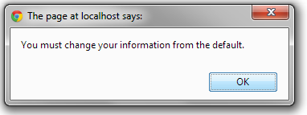

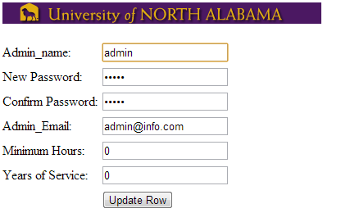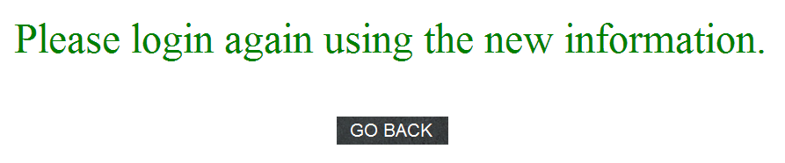

Admin will then be able to go back to login screen and log in regularly.

**1.2 Lost/forgotten passwords**

In the event of the admin forgetting their password they could have the server send the e-mail sent to them automatically.

Unfortunately at this time we do not have this e-mailing set up.

In the event of the admin forgetting his/her password he/she will have to have his/her fellow admin reset the password and inform him/her of the new password.

In the event that both admins forget their passwords the database must be accessed manually and the password reset there. **1.3 Semester Management**

**sub**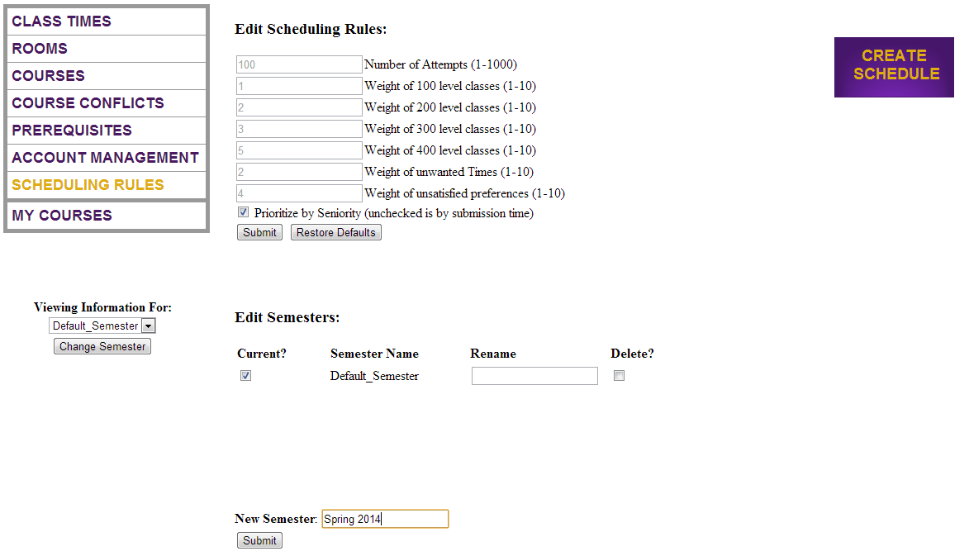

By entering in the **New Semester** field the admin can enter the name of a semester he/she would like to add and hit the **submit** button to submit the new semester.

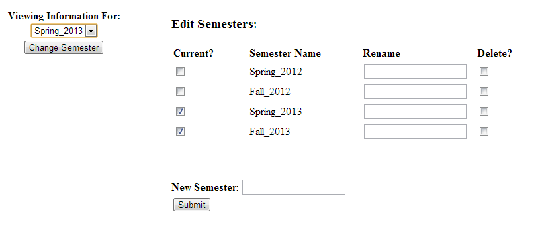

The admin can check the semesters they wish to be current under the **current?** check box field then refresh the page to update the change.

Faculty are able to enter preferences for the semesters that are checked as current.

To rename a semester simply enter the new name in the **Rename** field next to the semester name in the **Semester Name** field and refresh the page.

To delete a semester from the **Edit Semesters** field the admin can click the check box next to the semester under the **Delete?** field and refresh the change to update the change.

Semesters that are deleted from **Edit Semesters** are not deleted from archive, but simply removed from the **Edit Semesters** field.

**1.4 File Input**

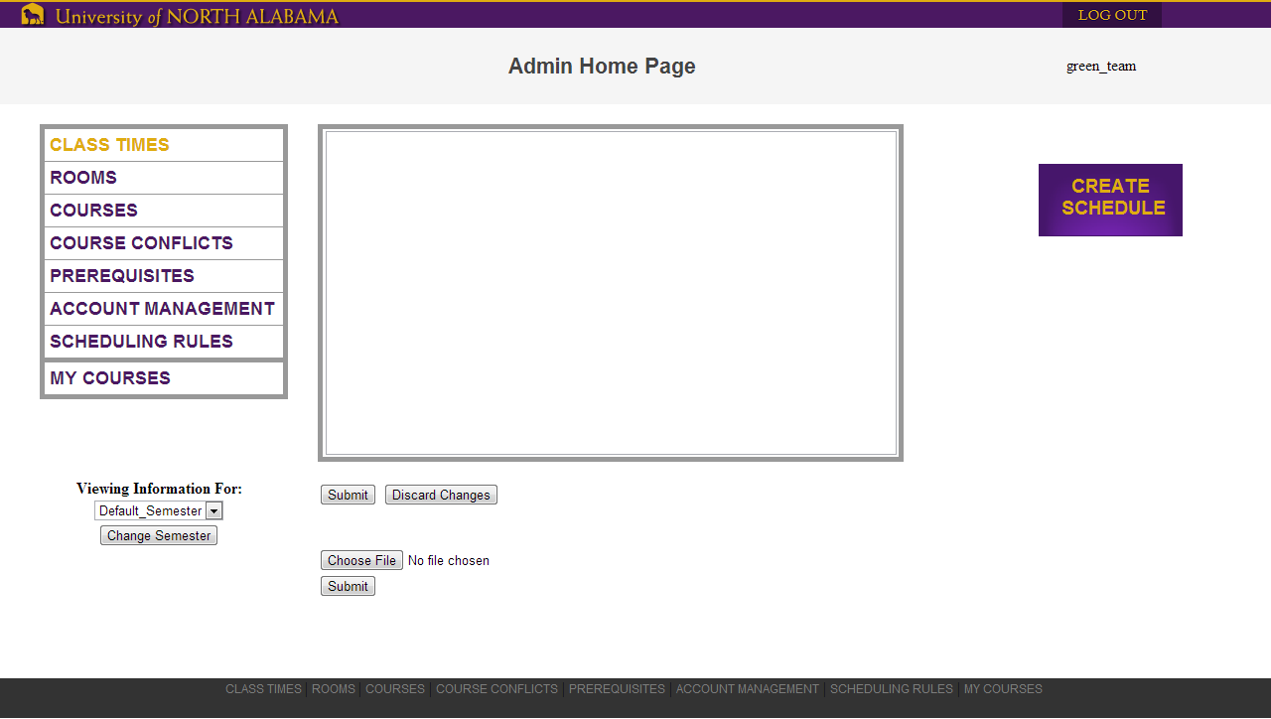

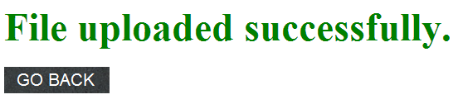

**File Errors will be displayed as the following:**

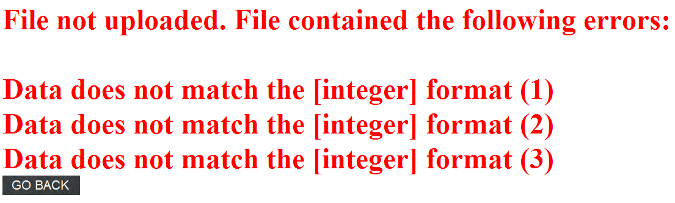

**Definition of File Formats with Examples**

**1.4.1: Class Times – Correct File**

**This is an example of a correct file:**

50 MWF/08:00 09:00 10:00 11:00 12:00 13:00 14:00

50 MTWR/08:00 09:00 10:00

75 MW/12:00 13:30 15:00

75 TR/08:00 09:30 11:00 12:30

165 M/18:00

165 T/18:00

**Description of fields**

Each line contains (in order):

1. An integer value that indicates, in minutes, the length of the course on this line.

1. A listing of the days each class is taught, specified by a letter (M, T, W, R, F, S), and not separated by spaces
   1. These symbols must be in chronological order. (RT) would not be valid for a Tuesday/Thursday class

1. A “/” symbol to signal the start of the time fields
   1. There are no spaces before or after the “/” symbol

1. A listing of times, separated by spaces, that signify the starting times of the classes
   1. These times must be in 24 hour format HH:MM
   2. Times before 11:00 must still include two hour characters (e.g., 8:00 would not be valid, but 08:00 would)

**1.4.1: Class Times – Faulty File**

**This is an example of an incorrect file (with added line numbers):**

1 50 M W F/08:00 09:00 10:00 11:00 12:00 13:00 14:00

2 50 MTWR 08:00 09:00 10:00

3 75 WM/12:00 13:30 15:00

4 75 TR/8:00 09:30 11:00 12:30

5 165 K/18:00

6 165 T / 18:00

**Note the following errors:**

|  |  |
| --- | --- |
| **Line Number** | **Error(s)** |
| 1 | There are spaces between each day |
| 2 | There is no “/” dividing the days from the times |
| 3 | The days are out of order |
| 4 | The 8am class is missing a padding 0 |
| 5 | This line does not list a valid day |
| 6 | There are spaces both before and after the “/” symbol |

**1.4.2: Available Rooms – Correct File**

**This is an example of a correct file:**

L 50 RABURN 210

C 40 RABURN 231

C 40 RABURN 232

C 40 RABURN 233

C 40 RABURN 234

C 40 RABURN 235

**Description of fields**

Each line contains (in order):

1. A single letter “C” or “L” to indicate the type of the classroom.
   1. “C” stands for classroom (lecture)
   2. “L” stands for lab

1. The size of the classroom or lab
   1. A single integer value that must be between 1 and 100 (inclusive)

1. A single upper case word that specifies a building name

1. The room number of the building
   1. must be between 1 and 9999 (inclusive)

**1.4.2: Available Rooms – Faulty File**

**This is an example of an incorrect file (with added line numbers):**

1          L            50            RABURN           210

2 C hi RABURN one

3 A 101 232

4 CL -1 RABURN 10000

5 C40RABURN234

6 C 40 RABURN 235 HELLO

**Note the following errors:**

|  |  |
| --- | --- |
| **Line Number** | **Error(s)** |
| 1 | There are more than 1 spaces between the fields |
| 2 | Room size and room number are not integer type, they are “hi” and “one” instead |
| 3 | invalid room type “A”; size is more than 100; building name is missing; |
| 4 | invalid room type “CL”; room size is negative; invalid room number 10000 |
| 5 | There is no space between all the fields |
| 6 | One extra field “HELLO”at the end of the line |

**1.4.3: Courses List – Correct File**

**This is an example of a correct file:**

BI101  5  0 0 30 C 4

BI101L 10 0 0 20 L 2

BI102  1  2 0 30 C 4

BI102L 3  1 0 20 L 2

BI111  2  0 0 30 C 4

BI111L 3  0 0 20 L 2

**Description of fields**

Each line contains (in order):

1. The title of the course. A course title consists of:
   1. 2-4 uppercase alphabetic characters specifying the department
   2. A 3 digit integer specifying the course number, in the range 099-499 (inclusive)
   3. (optionally) A single uppercase alphabetic character used in some courses (for example, L for lab or W for writing).
   4. A single space may occur between (a) and (b), but not between (b) and (c).

1. The number of daytime sections that are being offered for the course
   1. This must be an integer value between 0 and 100 (inclusive)
   2. Daytime classes include any class starting at or before 2:00 pm

1. The number of evening sections that are being offered for the course
   1. This must be an integer value between 0 and 100 (inclusive)
   2. Evening sections include any class starting after 2:00 pm

1. The number of internet sections that are being offered for the course
   1. This must be an integer value between 0 and 100 (inclusive)

1. The size of the class (ie., the maximum number of students allowed to sign up for a single section of the class)
   1. This must be an integer value between 1 and 100 (inclusive)

1. The classroom type required.  This must either be “C” for class or “L” for Lab

1. The number of semester hours an instructor would receive credit for.
   1. Must be an integer value between 1 and 12 (inclusive)

**1.4.3: Courses List – Faulty File**

**This is an example of an incorrect file (with added line numbers):**

1 BI101  5  0 0 0 C 15

2 BI101L 101 0 0 20 L 2

3 BI102  1  2 0 30 K

4 BI102L 3  0 20 L 0

5 BI511  2  0 0 30 C 4

6 BI111L 3  3 3 0 20 L 2

**Note the following errors:**

|  |  |
| --- | --- |
| **Line Number** | **Error(s)** |
| 1 | The class size is listed as 0. The course hours is >12. |
| 2 | There are 101 day sections being offered |
| 3 | The classroom type is listed as K. The course hours are missing. |
| 4 | This line does not have the proper amount of fields. The course hours is 0. |
| 5 | This listing is for a graduate class, which is not supported |
| 6 | There is an extra field in this line. |

**1.4.4: Conflict Times – Correct File (OPTIONAL)**

**This is an example of a correct file:**

CS 499 MWF/09:00 TR/09:30 W/18:00

CS 455 W/18:00

CS 360 MWF/09:00 MWF/10:00 MWF/12:00

CS355 TR/09:30 TR/11:00 MWF/12:00

CS335 TR/12:30 TR/18:00 MTWR/08:00

CS311W MWF/09:00 MWF/10:00 MWF/13:00

**Description of fields**

Each line contains (in order):

1. The title of the course. A course title consists of:
   1. 2-4 uppercase alphabetic characters specifying the department
   2. A 3 digit integer specifying the course number, in the range 099-499 (inclusive)
   3. (optionally) A single uppercase alphabetic character used in some courses (for example, L for lab or W for writing).
   4. A single space may occur between (a) and (b), but not between (b) and (c).

1. A listing of the days when the course cannot be taught, specified by a letter (M, T, W, R, F), and not separated by spaces
   1. These symbols must be in chronological order. (RT) would not be valid for a Tuesday/Thursday class

1. A “/” symbol to signal the time field
   1. There are no spaces before or after the “/” symbol

1. The time for which the course cannot be taught, which must be in HH:MM format

1. There can be more than one conflict time per course on the same line

**1.4.4: Conflict Times – Faulty File**

**This is an example of an incorrect file (with added line numbers):**

1 CS   499 MWF / 09:00 TR / 09:30 W / 18:00

2 CS 455 W/111:22222

3 CS 999 MWF/24:60:00 MWF/25:61 MWF/99:01

4 CS355 RT/09:30 RT/11:00 MWF/12:00

5 CS335 TR/12:30 AB/18:00 mtwr/08:00

6 CS311E MWF/09:00 MWF/10:00 MWF/13:00

**Note the following errors:**

|  |  |
| --- | --- |
| **Line Number** | **Error(s)** |
| 1 | Two spaces between “CS” and “499”, spaces before and after “/” |
| 2 | Time format error |
| 3 | Course number exceeds limit; time’s hours and minutes exceed limits |
| 4 | Days are in wrong order “RT” |
| 5 | Days format errors |
| 6 | Invalid course “CS311E”, “E” is an invalid letter after course number |

**1.4.5: Prerequisites – Correct File (OPTIONAL)**

**This is an example of a correct file:**

CIS225 CIS125 CIS125H

CIS236 CIS125 CIS125H

CIS315 CIS225 CIS236

CIS330 CIS225 CIS236

CIS350 CIS236

CIS366 CIS225

**Description of fields**

Each line contains (in order):

1. The title of the course. A course title consists of:
   1. 2-4 uppercase alphabetic characters specifying the department
   2. A 3 digit integer specifying the course number, in the range 099-499 (inclusive)
   3. (optionally) A single uppercase alphabetic character used in some courses (for example, L for lab or W for writing).
   4. A single space may occur between (a) and (b), but not between (b) and (c).

1. One or more fields listing the titles of the classes that are prerequisites to the first field
   1. A class may not require itself
      1. Outside of this, there is no checking for cycles within the file.  For example, CS355 could require CS255 while CS255 requires CS355.  Prevention of these logic errors is left to the administrator and is outside the scope of this program

**1.4.5: Prerequisites – Faulty File**

**This is an example of an incorrect file (with added line numbers):**

1 CIS225 CIS125 CIS125K

2 CIS236 CIS125 CIS125

3 CIS315 CIS315

4 CIS330

5 CIS350 CIS366

6 CIS366 CIS350

**Note the following errors:**

|  |  |
| --- | --- |
| **Line Number** | **Error(s)** |
| 1 | The last prerequisite is not a valid class |
| 2 | This class lists the same prerequisite twice |
| 3 | This class requires itself |
| 4 | There are no prerequisites listed for this class |
| 5 & 6 | These lines are correct, but there is a logical error which would result in undesirable behavior.  However, accepting such input is a limitation of the application. |

**1.4.6: Faculty Members – Correct File**

**This is an example of a correct file:**

Adam, Larry 5.5 alarry@una.edu 12

Aguado, Alex 60 aalex@una.edu 12

Armstrong, Linda 0 alinda@una.edu 18

AJ., Birdie 5 bbirdie@una.edu 12

Baird, Paul 5 bpaul@una.edu 12

Cagle, Corey 5 ccorey@una.edu 12

**Description of fields**

Each line contains (in order):

1. Last name of the faculty, followed by the comma symbol “,”
   1. This field is allowed to contain any symbol except ‘,’ (comma) or spaces

1. First name of the faculty which is one space after the “,” symbol
   1. This field is allowed to contain any symbol except ‘,’ (comma) or spaces

1. A positive number indicating the faculty member’s years of service
   1. Must between 0 and 60 (inclusive)
   2. May include a fractional portion of 0.5 to represent a single semester.

1. The faculty’s email address
   1. This is also used as the faculty’s account name
   2. Each email address must be unique

1. The hours that the faculty is teaching for the current semester
   1. Must an integer between 1 and 18 (inclusive)

**1.4.6: Faculty Members – Faulty File**

**This is an example of an incorrect file (with added line numbers):**

1 Adam,Larry 5.5 alarry@una.edu 12

2 Aguado, Alex 3.2 aalex@una.edu 12.2

3 AJ., Linda 61 alinda@una.edu 19

4 Last, Middle, First 5 bbirdie@una.edu 9

5 B,aird, Paul 5 bpaul@una.edu 12

6 Cagle, Corey -1 ccorey@una.edu -1

**Note the following errors:**

|  |  |
| --- | --- |
| **Line Number** | **Error(s)** |
| 1 | No space betweeen “,” and first name |
| 2 | Years of service and minimum hours format errors |
| 3 | Years of service and minimum hours exceed the limits |
| 4 | Name is in wrong format |
| 5 | Last name contains a comma |
| 6 | Years of service and minimum hours are negative numbers |

**1.5 Account Management**

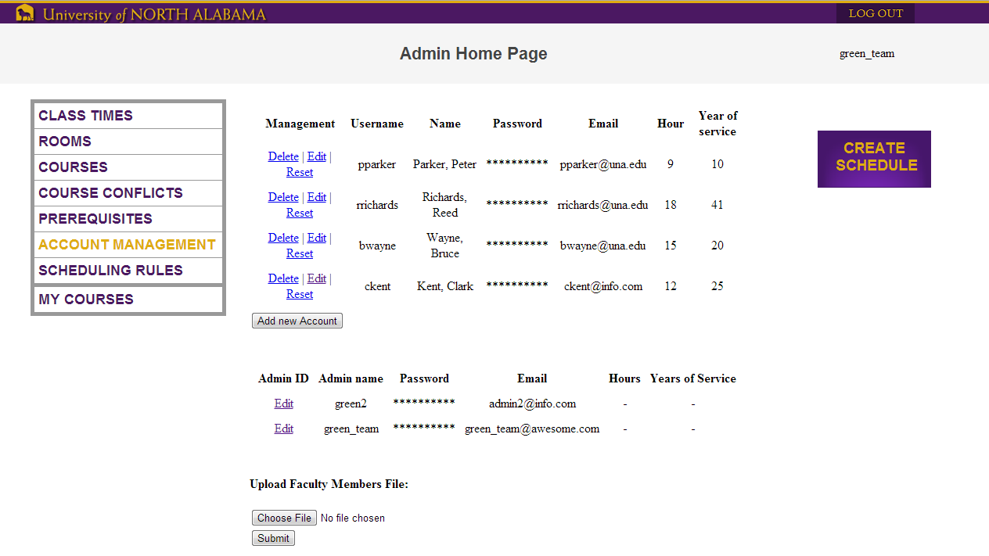

The Admin can manage faculty accounts by using the Delete, Edit, and Reset buttons under the **Management** field on the Account Management page.

The admin will be able to add accounts by clicking the **add new account** button.

The admin is allowed to edit his/her own account information as well as the account information of the other admin.

The admin also has the option of uploading faculty member files by **choosing a file** then **submitting** their file.

**1.6 Generating schedule**

Admins have the ability of generating schedules for particular semesters.



Admin will be able to:

There is a default_Semester schedule that is functional, but does not have any faculty’s preferences considered. Can be deleted once an actual schedule is created.

If all schedules are deleted the Default_Semester will be recreated and be the default.

Control how many attempts the scheduling algorithm will make to generate a good schedule.

Control the weight(importance) of the different levels of classes. This will allow the user to increase the importance of various levels of classes if needed.

A check box at the bottom of Edit Scheduling Rules allows Admin to be able to control wheather the scheduling algorithm is based off Seniority or submission time.

The user will be able to **enter a new semester** and hit **submit** to create a new schedule file for that semester.

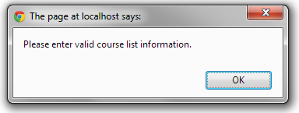

This is the error message for incorrect schedule information.

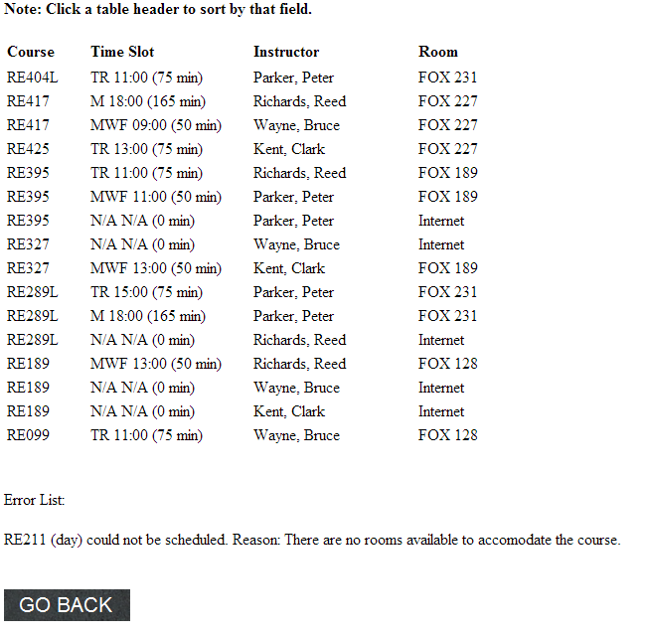

This is an example of the graphical output of a schedule.

By clicking any of the headers the schedule can be organized by **Course, Time Slot, Instructor,** or **Room**.

Under that schedule is the **Error List** which is the list of classes that **could not be scheduled** and the reason the class could not be scheduled.

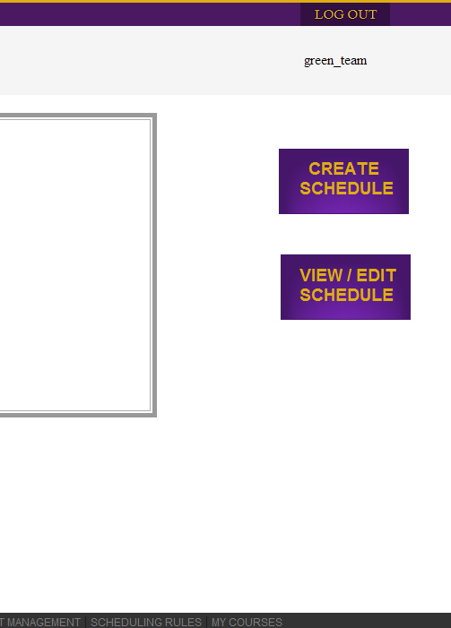

To create a schedule the admin will have to hit the **Create Schedule** button on the **Scheduling Rules** page.

To **View the Schedule/Edit** the schedule click the **View/Edit Schedule** button.

**2. Faculty Use**

**2.1 Logging in**

**2.1.1 Username Constraints**

Faculty account usernames will be the email address provided by the administrator in the faculty account input file, and must be unique.

**2.1.2 User Password Constraints**

* 1. Must be 6 to 9 characters long, inclusive.
  2. Passwords are case sensitive.
  3. Passwords must begin with an alphabetic character
  4. Must contain at least one numeric character
  5. Must contain at least one of the following characters: an exclamation point (!), a question mark (?), or a comma (,).

**2.1.3 First Login**

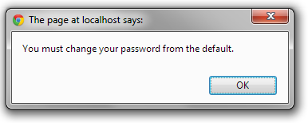.

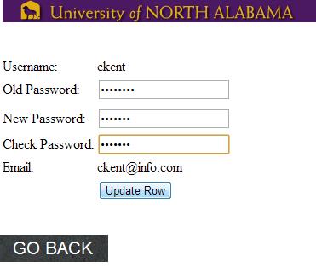



1. Upon first login the User will be required to change their default passwords
2. After entering in the new password the faculty user will be redirected to the login page to login normally.

**2.2 Lost/forgotten passwords**

Should faculty user forget or lose their password the faculty user will have to contact their admin to receive a temporary password.

**2.3 Home Page & Selecting Semester**

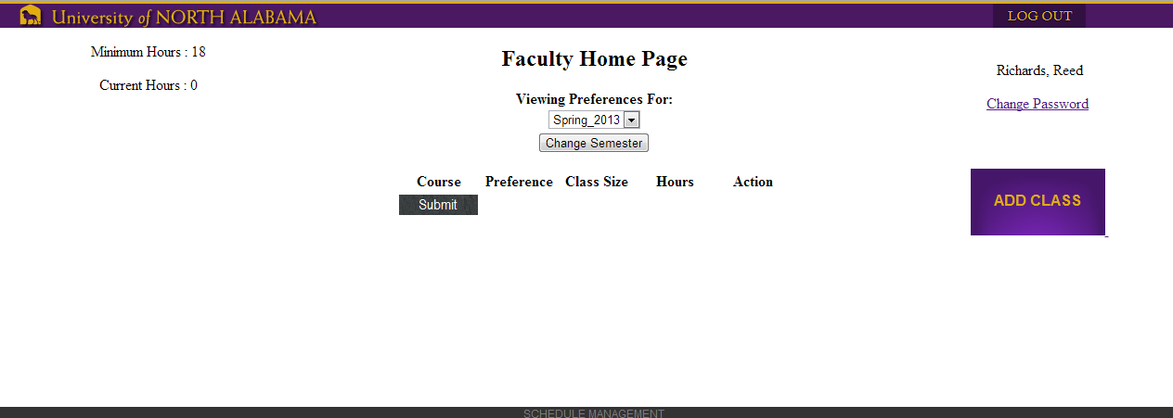

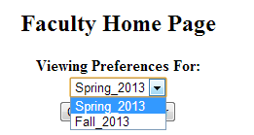

To choose a semester to enter preferences for the faculty user will have to select one of the semesters from the **Viewing Preferences For:** drop down list on the Faculty Home Page and hit the **Change Semester** button to submit the semester change.

**2.4 Adding Preferences**

To enter preferences the user will have to hit the **Add Class** button.

From there the user can select classes from the check list of courses and enter in their time preferences (**morning, midday, evening**).

If no time preference is selected **midday** is the **default time slot**.

Faculty users are allowed to enter up to their allowed minimum hours in preferences.

**Minimum Hours** and **Current Hours** can be viewed on the top left hand of the screen.

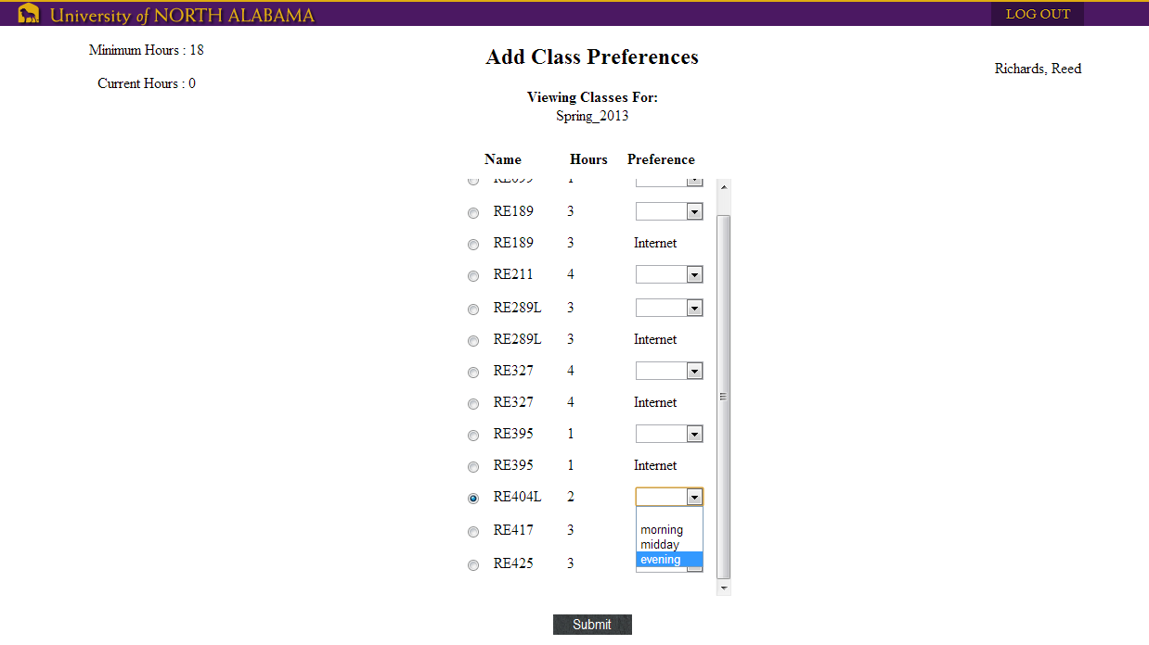

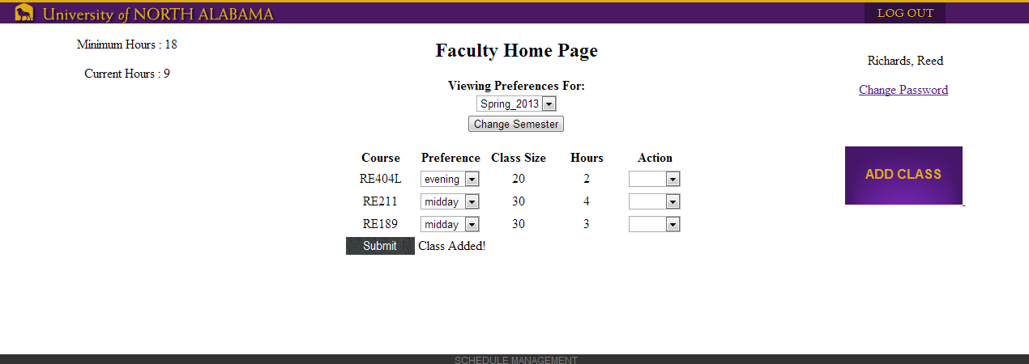

Faculty will be able to view their preferences and Edit their on their Home Page.